AM 24 EXERCISE 1 – Predator/Prey

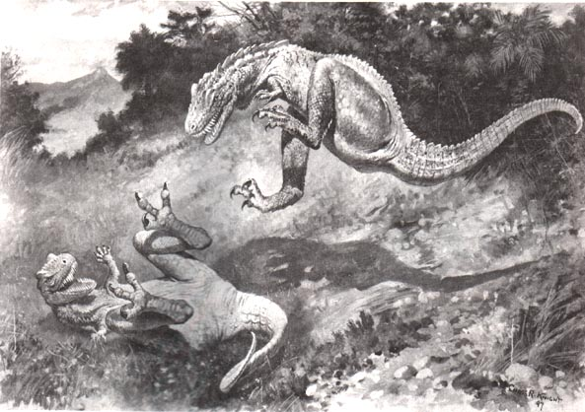

System to build
In a 2-dimensional grid world societies of predators and preys live. The goal of the predators is to “capture” the prey, by occupying the same position as the prey. The predators and the prey can move to any of the adjacent eight squares in the grid. The prey moves randomly in the world being slower than the predators (e.g. occasionally staying still on a square). The predators have limited visibility range, and thus explore the environment until they find prey to capture.

Questions to answer
- Briefly analyse the problem of the exercise from a MAS perspective.
- Implement your first MAS system in MadKit based on your analysis.
- Experiment with the properties of the agents and how they affect convergence:
  - Visibility range of the predators.
  - The ratio of the speed of predators/prey.
- Experiment with the parameters of the world and how they affect convergence:
  - Size of the world.
  - Number of predators/preys in the world and the ratio.
  - The world being a torus or not.

